Experiment 8

**Name** : Mohammad Wasi

**SAP ID** : 500110709

**Batch** : AIML B8

Aim: **.** To understand the concepts of Sequence.**.**

**Objective :** Students will be able to implement the concept of sequence

Theory :

In SQL, a sequence generates unique numeric values, often used for primary keys. Syntax for creation includes START WITH and INCREMENT BY clauses. Retrieval uses NEXTVAL('sequence_name') for the next value and CURRVAL('sequence_name') for the current one. ALTER SEQUENCE allows modification, adjusting parameters like increment and maximum value. Deletion is achieved with DROP SEQUENCE. These commands streamline key assignment and management in database systems.

**Code**

**-- 1) Create a sequence by name EMPID_SEQ starting with value 100 with an interval of 1.**

CREATE SEQUENCE EMPID_SEQ START WITH 100 INCREMENT BY 1;

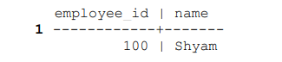

**-- 2) Write a SQL command for finding the current and the next status of EMPID_SEQ.**

SELECT last_value AS current_value, nextval('EMPID_SEQ') AS Next_val FROM EMPID_SEQ;

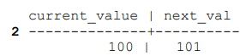

**-- 3) Change the Cache value of the sequence EMPID_SEQ to 20 and maxvalue to 1000.**

ALTER SEQUENCE EMPID_SEQ CACHE 20;

ALTER SEQUENCE EMPID_SEQ MAXVALUE 1000;

**-- 4) Insert values in employees table using sequences for employee_id column.**

INSERT INTO employees VALUES (nextval('EMPID_SEQ'), 'Shashank'),

(nextval('EMPID_SEQ'), 'Roshan'),

(nextval('EMPID_SEQ'), 'Vansh');

SELECT * FROM employees;

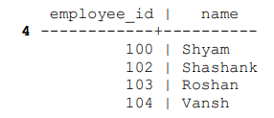

**-- 5) Drop sequence EMPID_SEQ.**

DROP SEQUENCE EMPID_SEQ;